Blitz Reports Schedule Process

Blitz uses the same functionality for scheduling Requests. One “gotcha” is that users cannot use List of Values which scheduling. Therefore, the Blitz Team recommends copying a previously submitted report and then scheduling..

Oracle Application --> Choose Responsibility --> Blitz Reports in Menu -->
Query the Report Name and Pass the Parameters.

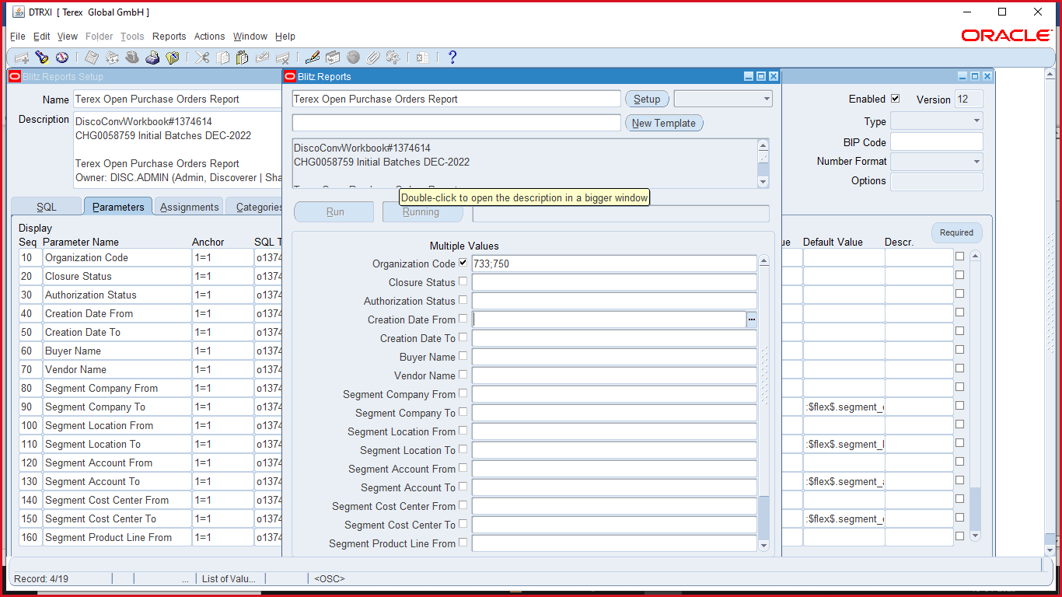

Once completed the request. Copy the single Request.

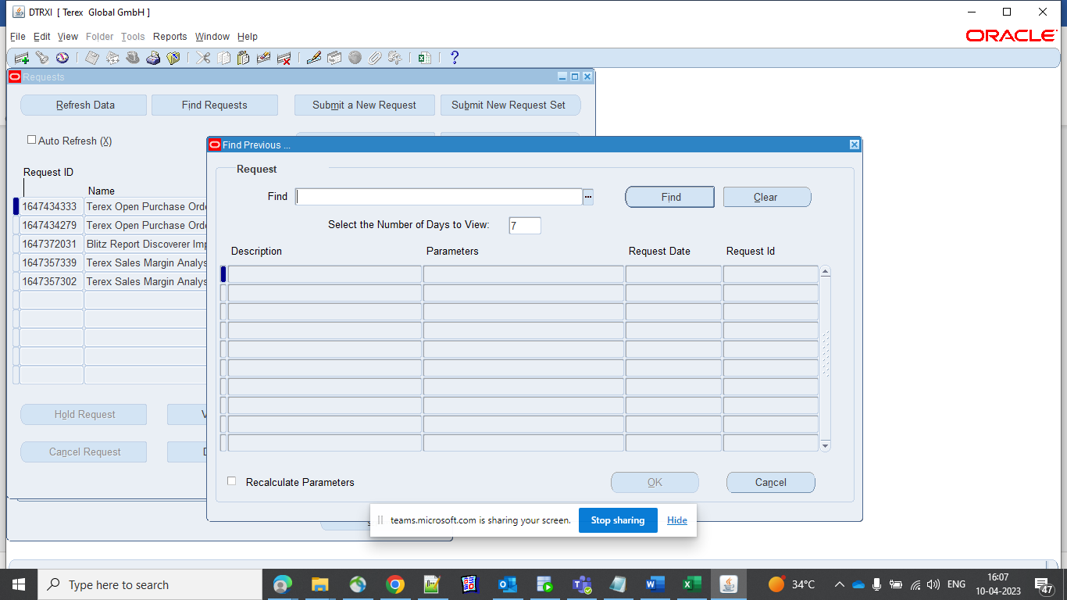

Click on Find button and choose the report then Click ok

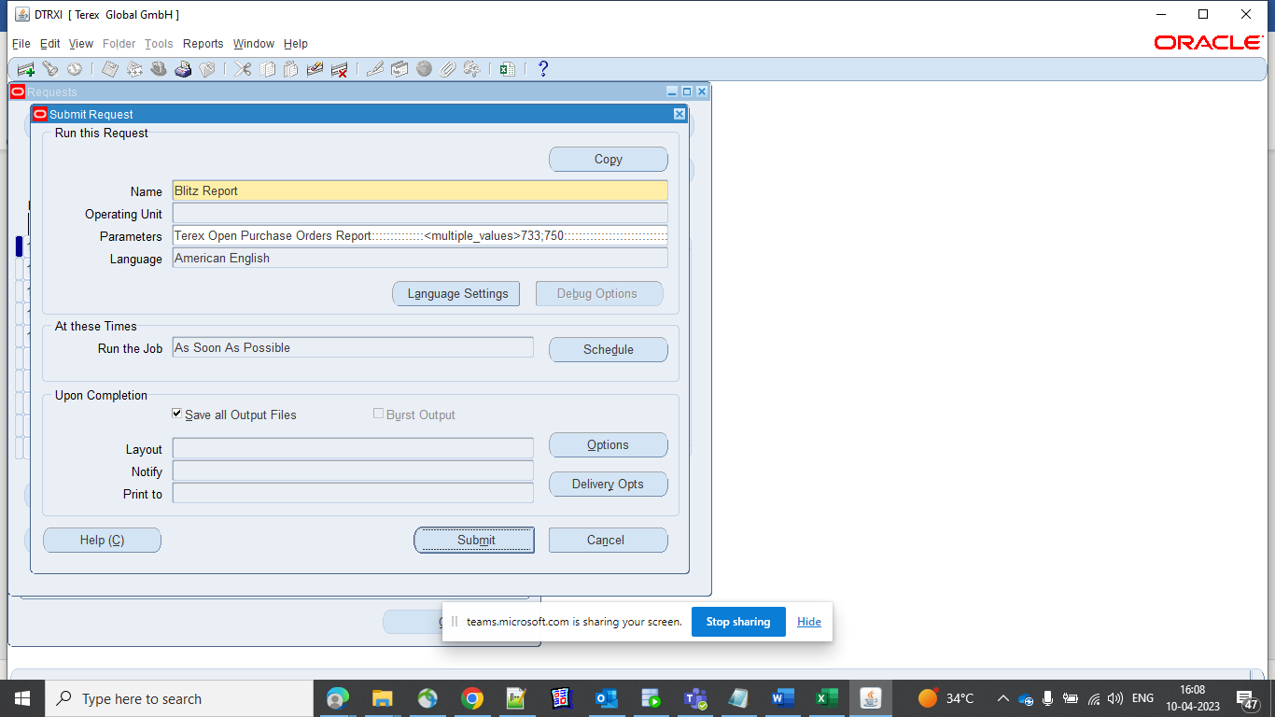

Click on Parameters and Check
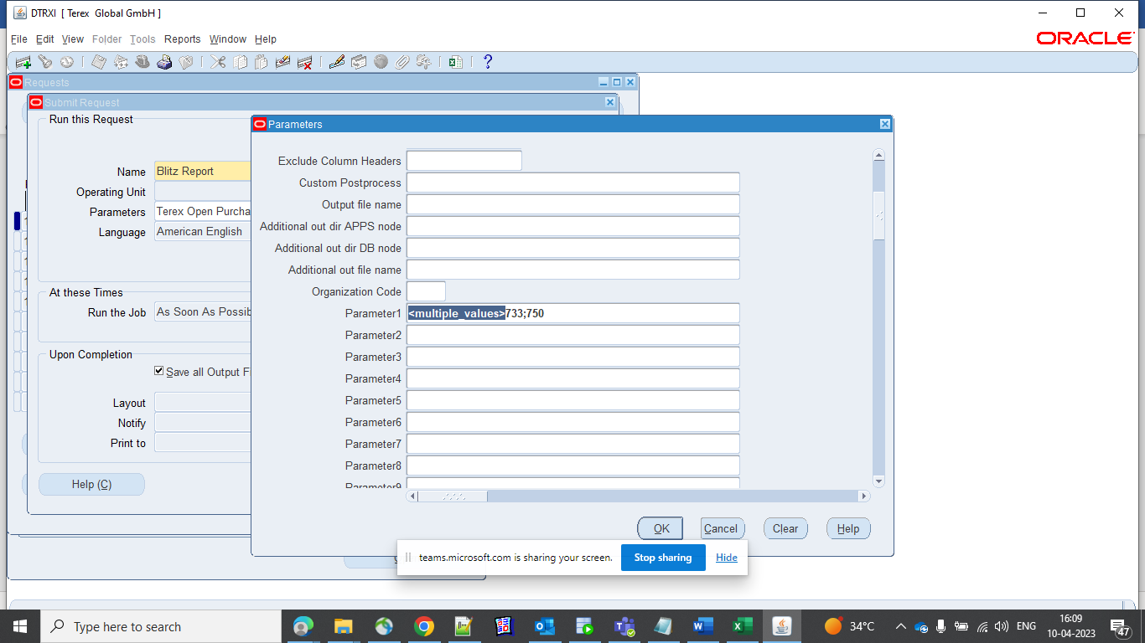
Same as it is and click ok

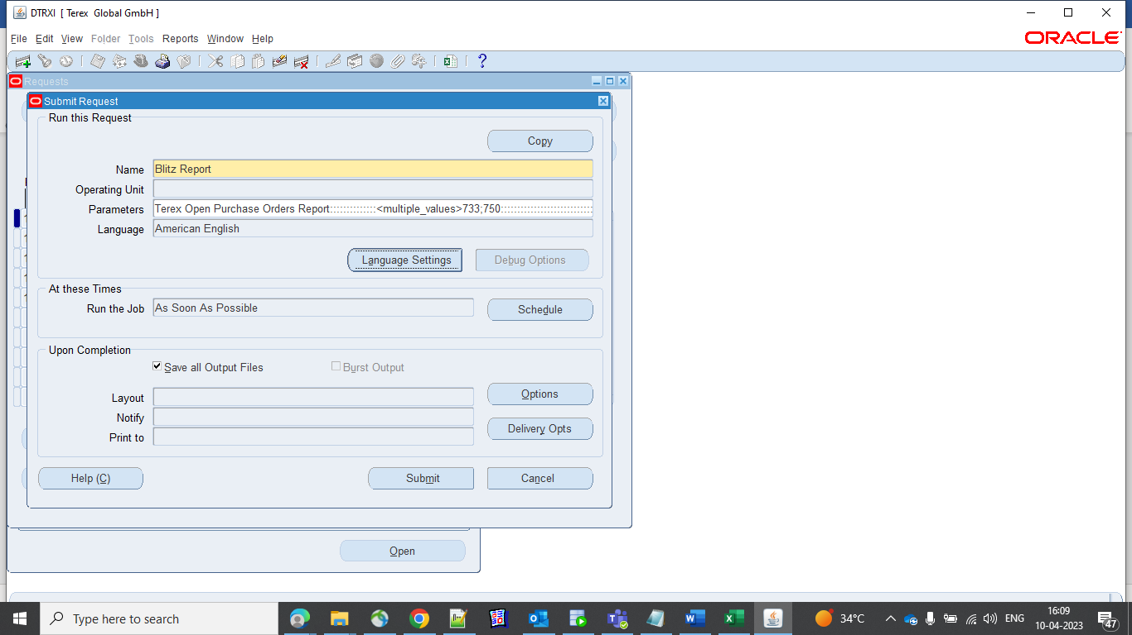

Then click on Delivery Opts button
To choose the Email and add the emal address, choose the language.

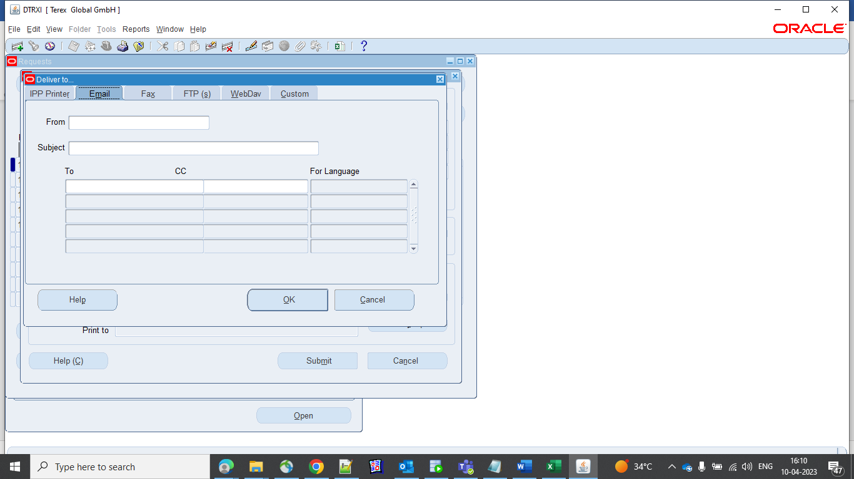

Then click ok and schedule button

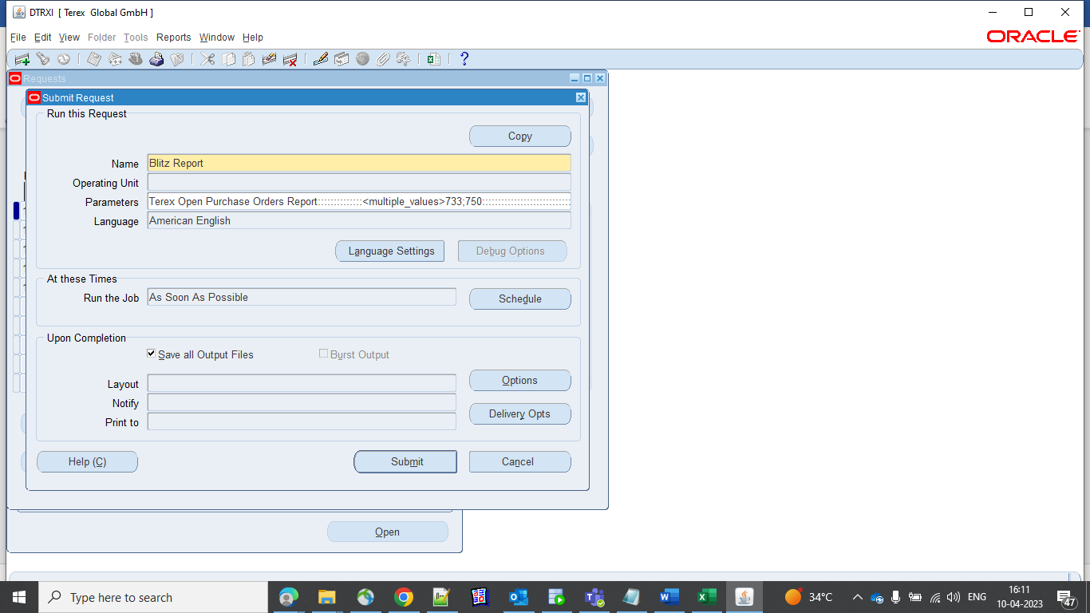

Choose the Specific Days

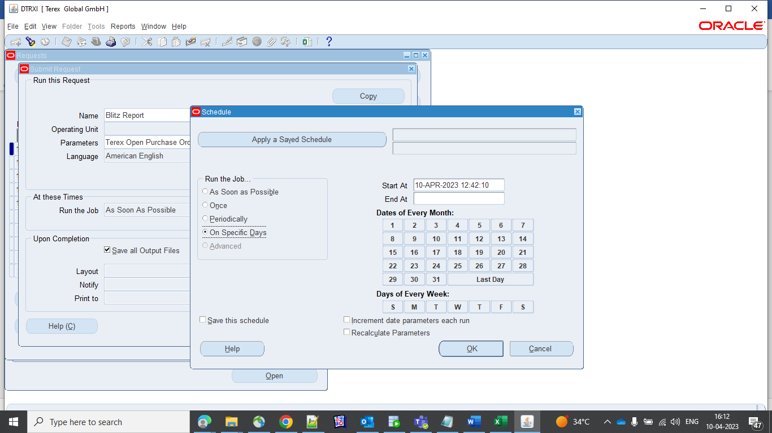
And click ok
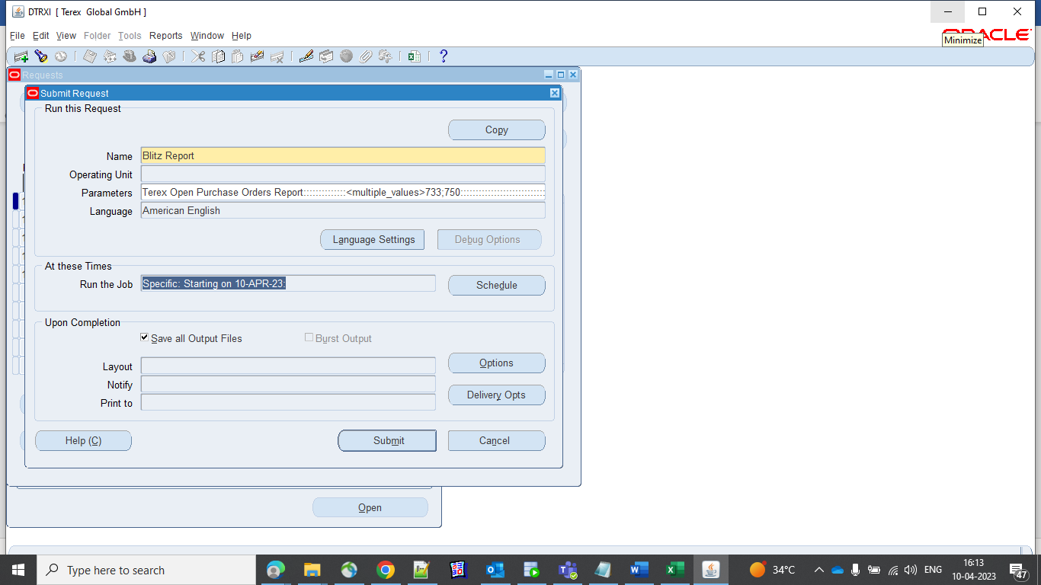

And submit the request.

Please note, this will be submitted under the user’s own name. Other users who share the same responsibility can view the outputs (role-based access control is already enabled in Production).

